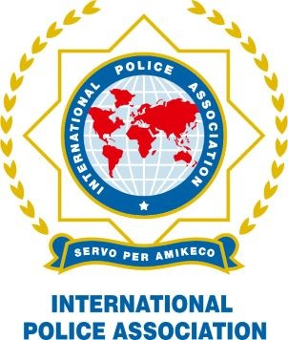

Kyriakos Karkalis CSCC - VP

CSCC.VP@ieb-ipa.org
INTERNATIONAL PHOTOGRAPHY COMPETITION 2023

Organised by the Socio-Cultural Commission of the IPA

ENTRY FORM 2023


INTERNATIONAL POLICE ASSOCIATION – INTERNTIONAL EXECUTIVE BOARD
NGO in Consultative (Special) Status with the Economic and Social Council of the United Nations; in Consultative Status with the Organization of American States and UNESCO
1

Name:
IPA Section:
Category:
Address:
Email:

Brief description of every photo submitted:

By submitting these photos, I and all persons pictured in the photos authorise the IPA to use the photos for this competition, in IPA publications, on IPA websites and social media.
Please submit all photos together with this form to SCC Member- Competition Head-Kyriacos Perikleous (Kikis) IPA CYPRUS, at: kikis03@cytanet.com.cy

Kyriakos Karkalis
Chairperson Socio-Cultural Commission Vice President

